Data Science Libraries:

Why Library:

very complex

implementation can be much more efficient

our implementation might not be last

**PIP is app store for python**

syntax:

pip install <package name>

how to check is python package installed or not

install package in jupyter notebook

syntax is :

!pip install pandas

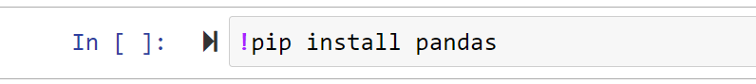

create environment

to check methods from imported library

syntax : dir(package_name)

